American Barn
Specification

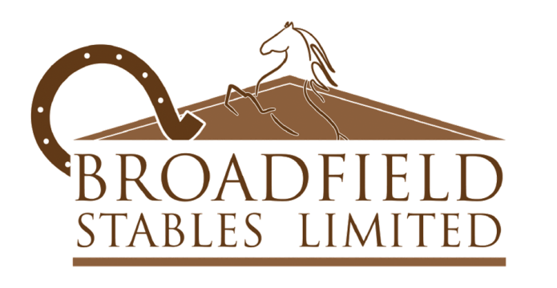
Specification

Main Structure |  | All timbers are pressure treated. 2.4m eaves (not inc. bricks). Ridge – dependent on width of building approx. 4.0m.
Cladding |  | Premium ex19x125mm overlap shiplap fixed with 45mm sheridized ring -shank nails. Rainwater skirt fitted to all backs and end walls to prevent water ingression at base of panels.
Framework |  | 100x50mm cls timber with vertical studwork at approx. 600m centres.
Fixing to Base |  | Bolted to base by 200mm thru bolts at approx. 1.2m centres directly into concrete base.
Door Frames and Openings |  | Sliding Barn door openings 2.4m.
Internal Lining |  | Building lined to eaves with 12mm Hardwood faced Plywood.
Windows |  | One per stable on side elevation as standard 600x900mm part louvered timber framed window. Top part ventilated with lower part glazed with 3mm acrylic protected with 12mm galvanised bars on the interior. Can be replaced with top stable door at extra cost.
Overhang/Canopy |  | Can be added to outside elevation but no overhang included in standard design.
Outer end Door Pairs |  | Sliding – on both end elevations.  2.4m wide aperture by 2.10m high (inc. single brick course of 80mm)  - Clad with ex 125x19mm V jointed tongue & grooved planed timber  - 150x28mm braced framework to interior  - 1 x 100mm hasp and staple latch (Padlock not supplied_  - Securing inside of first door – 300mm heavy – duty floor bolt drilled into concrete.  - Weather canopy fitted above both end doors.
Roofing Structure |  | 225x75mm Rafters  Sawn Timber purlins 125x50mm or 100x50mm  150x75mm timer posts supporting main 225x75mm rafters, fixed to base in galvanised angle.  Roof fitted with 11mm OSB boarding over purlins.
Roofing Finishes |  | Standard roofing in Black Onduline and ridge. Alternative colours at additional cost.  1 clear roof sheet fitted per internal stables as standard in matching profile. P6 cement fibre roofing is available.
Guttering |  | 112m black uPVC gutters fitted with 68mm down pipes to both side elevations. Down – pipes finished with curved shoes at base – connecting down-pipes directly into ground drainage is the responsibly of client.
Internal Stables | Standard steel partitions with choice of infill. 2.260mm high, 22m diameter bars at 53mm spacing.
Tack Rooms/  Feed Rooms | Fitted in place of 1 internal stable if requested. Please refer to price list.  Front partition contains one personal door (See tack room/feed room listed prior)  Flat roof above constructed of 125x47mm joists at 400mm centre’s held by joist hangers and lined over with 18mm OSB boarding.  All paritions for internal tack/feed rooms supplied fully lined to eaves in 12mm plywood.  Internal Tack/Feed Room doors
900mm wide x 2.020m high x 44m thickness
- Softwood FLB door
- 150x28mm ledged & braced framework
- Fiver lever mortice lock fitted with black lever handle
- Three 75mm butt hinges
- Inward opening
Treatment –  Exterior Finish | All timbers with exception of any sheet material are vacuum/pressure impregnated treated.
Installations | Following completion of the buildings a one week break is recommended before subsequent contractors are allowed to other services to allow for possible delays. All installation schedules are estimated only.
Optional Extras | Alternative coloured Onduline roofing  P6 corrugated cement roofing and in alternative colours  Onduvilla roof finish (minimum roof pitches apply)  Full stables doors to outer – walls  Top back doors to outer walls  6” weatherboard cladding  Clock towers  Weathervanes  Exterior building standing dark brown or black.

